

FAMILY PRACTICE
Armada Road, Whitchurch, BRISTOL BS14 0SU. TEL: 01275 832285
GP Partners; Dr K Jones & Dr I Da Costa & Dr J Frawley.

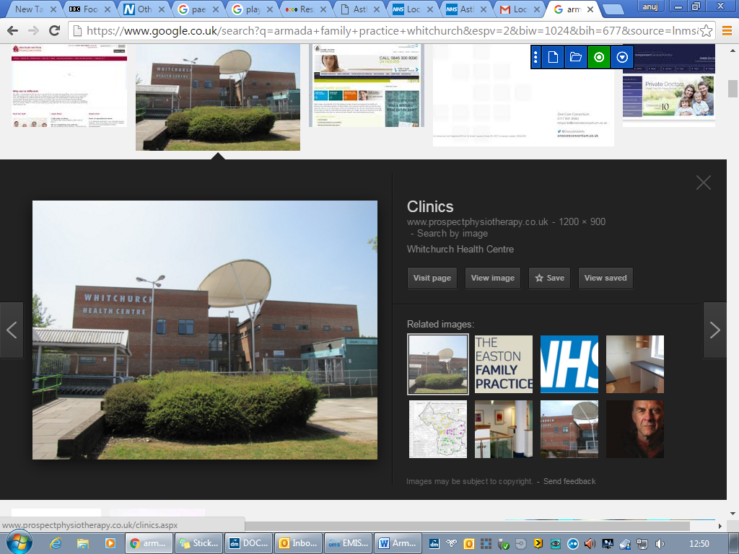
Great opportunity to join a friendly and supportive practice

Pharmacy Technician - part time 20-25 hours per week

About us

The Armada Family Practice works from a modern purpose-built health centre with a practice population of circa 16,300 patients. We are looking for an experienced pharmacy technician to join our multi-disciplinary team.

Our clinical team comprises of 3 GP Partners, Salaried GPs, Advanced Nurse Practitioners, Paramedic Practitioner, MSK specialist, Practice Community Nurses, Practice Pharmacists and prescription clerks, Practice nurses, HCAs, GP assistants and a large administration team.

- Excellent employment package
- Compact practice area with easy parking.
- Training Practice
- Regular practice meetings and training opportunities
- EMIS Web clinical system
- CQC rated “Good”

All our appointments are booked by our experienced care navigation team who ensure that patients are booked in with the right clinicians to help the patient. They use a navigation tool called Sentier’s which has been adapted to meet our needs and appointment system. Helping to ensure the right patient sees the right clinician first time.

Job Description

Key Responsibilities
- Carry out medicines’ reconciliation following hospital discharge
- Manage repeat prescription processes and ensure accuracy
- Support prescription queries and liaise with community pharmacies
- Assist in audits related to prescribing and medicines safety
- Identify and action prescribing safety alerts
- Support systems for monitoring and recall of long-term condition medications
- Identify and reduce medication errors and improve systems
- Support medication reviews and prescription processes for care home residents within scope of practice
- Support patients with medication understanding and adherence
- Update and maintain accurate patient medication records

What we are looking for

Essential:
- Qualified Pharmacy Technician with current registration with General Pharmaceutical Council (GPhC)
- Experience working in pharmacy (community, hospital, or primary care)
- Strong attention to detail and organisational skills
- Good communication and teamwork abilities
- Knowledge of medicines management and safety

Desirable:
- Experience in primary care or GP practice setting
- Understanding of NHS prescribing systems (e.g. EMIS)
- Accuracy checking qualification (ACT)
- Experience with audits or quality improvement
Salary:

- Depending on experience
- We are a visa sponsoring practice

For further information or to apply for this role please contact Victoria Fyfe - Practice manager
Victoria.fyfe1@nhs.net

